Website Blog Project

Author: Ce Guo (Phoenix)
Update time: February 28, 2021

Website Blog Project 1
1. Requirements and functionality design 2
1.1 Project requirements 2
1.2 Functionality design 4
2. Technology design 9
2.1 Architecture design 9
2.2 Development dependence 9
3. Database design 11
3.1 DataTable design 11
4. Interfaces design 14
4.1 Server-side interfaces design 14
4.2 Front-side interfaces design 16
5. Security 18

Requirements and functionality design

Project requirements

Background requirements
Develop and deploy a personal web blog, which showcases your competences and expertise. At least one of the posts should be a reflective post on security, quality and usability within software projects.

Your web blog should allow your visitors to browse through the posts (articles) you have published, get information about your competences and expertise, leave comments on your posts, and contact you using email and social media.

Interface requirements
- header with navigation bar to enable the visitors to access all pages;
- section that displays the main content, e.g., the most important or latest blog posts;
- footer containing relevant links to additional information, e.g., contact details, privacy policy, disclaimer, etc.;
- you can also include a side bar to display any information you think is relevant and makes your website more attractive and usable.

Functionality requirements
- Home page should allow visitors to:
- view most important or recent blog posts (up to you to decide which posts you want to display) in the main content section of the page;
- click on a post (either the post’s title or image) so that the visitor views detailed information about the selected post;
- access login or registration pages (see explanation of content and functionality of these pages later);
- see personalized greeting in the top navigation bar if they are logged in, e.g., a logged in customer will be greeted by their first name (e.g., ’Hello, Jane!’). The visitor, who is not registered or logged it will see ’Hello, Guest!’ message.
- The individual blog post page should be used to display detailed information about a particular post, and allow the visitors to post comments. At least one of these posts should be a reflective post on security, quality and usability within software projects.
- ’All posts’ page should display all posts that you have ever created, and it should:
- Allow the visitors to access any post they wish to view.
- Be able to sort the posts by ascending or descending date.
- Registration page which should:
- Ask the visitors, who wish to register, to provide their first and last name, email address (which will they use to log in) and password.
- Perform a simple check that the visitor input their email address in the expected format, e.g., my_email@some_domain.com. (Note: this should be a simple check for the email address format - there is no need to check if this email address actually exists.)
– On successful registration the website should display a message to inform the user and redirect to home page.
– If registration is unsuccessful, the user should be informed, and will not be redirected to any other page.
- Inform the visitor if the registration is successful; or display a meaningful error message if there is a problem with the registration.
- Log in page which should:
- Enable a registered visitor to log in, and if successful, the visitor is redirected to the home page.
- Display an error message if there is a problem with a visitor’s login. NB: make sure that error messages do not jeopardize your website’s security.
- Allow a logged-in user to log out.
You might also want to develop more advanced functionality to earn additional marks:
- Search engine to allow the visitors to locate information on your website, e.g., to perform a search based on the posts’ titles or content;
- Ability for the user to rate each post, e.g., using ’like’ or ’star’ options. The ratings for each post should then be updated and displayed.
- Ability for the users to tag certain posts, after which a list of the tagged items is stored in the user’s account, and the user is able to access the list as well as delete certain tagged items from that list.

Functionality design
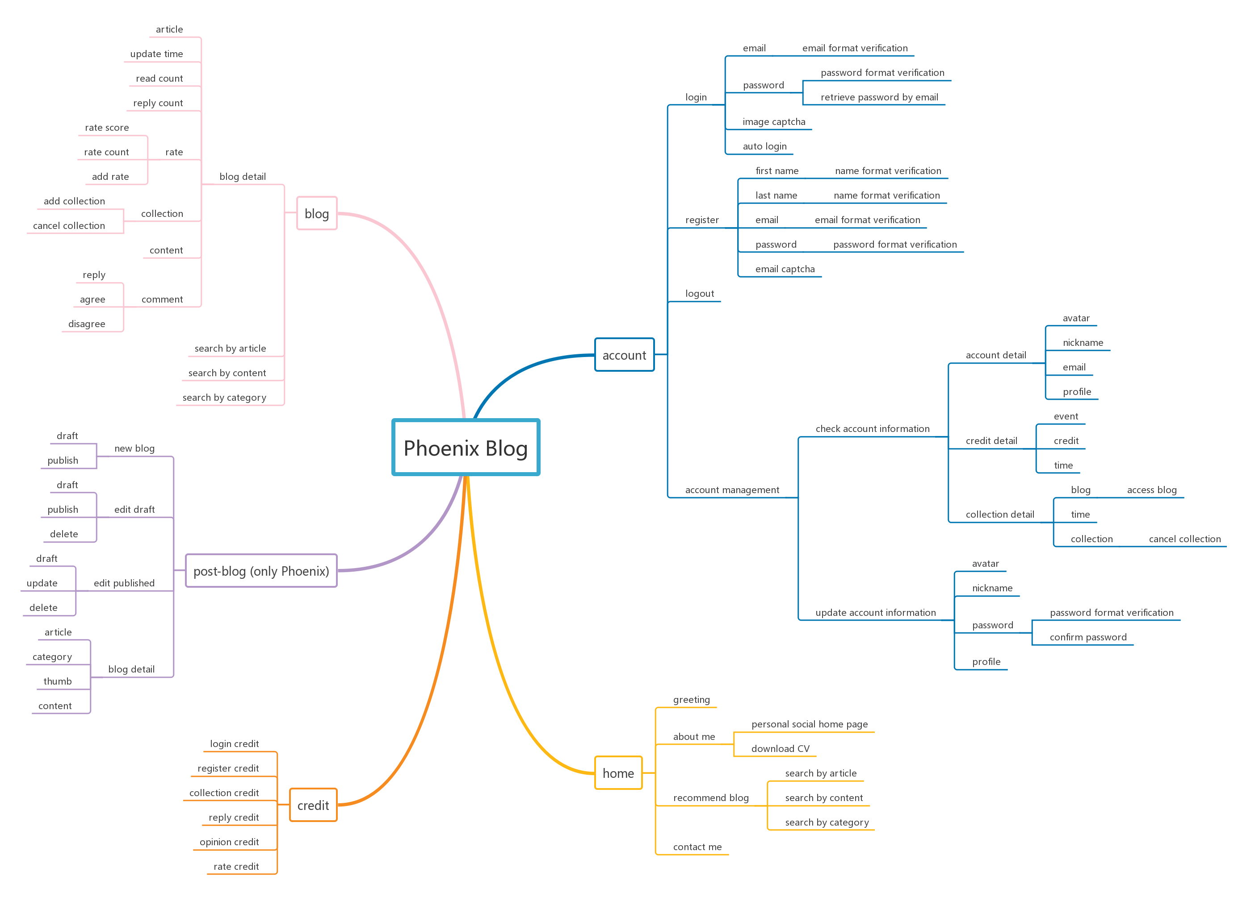

Functionality account
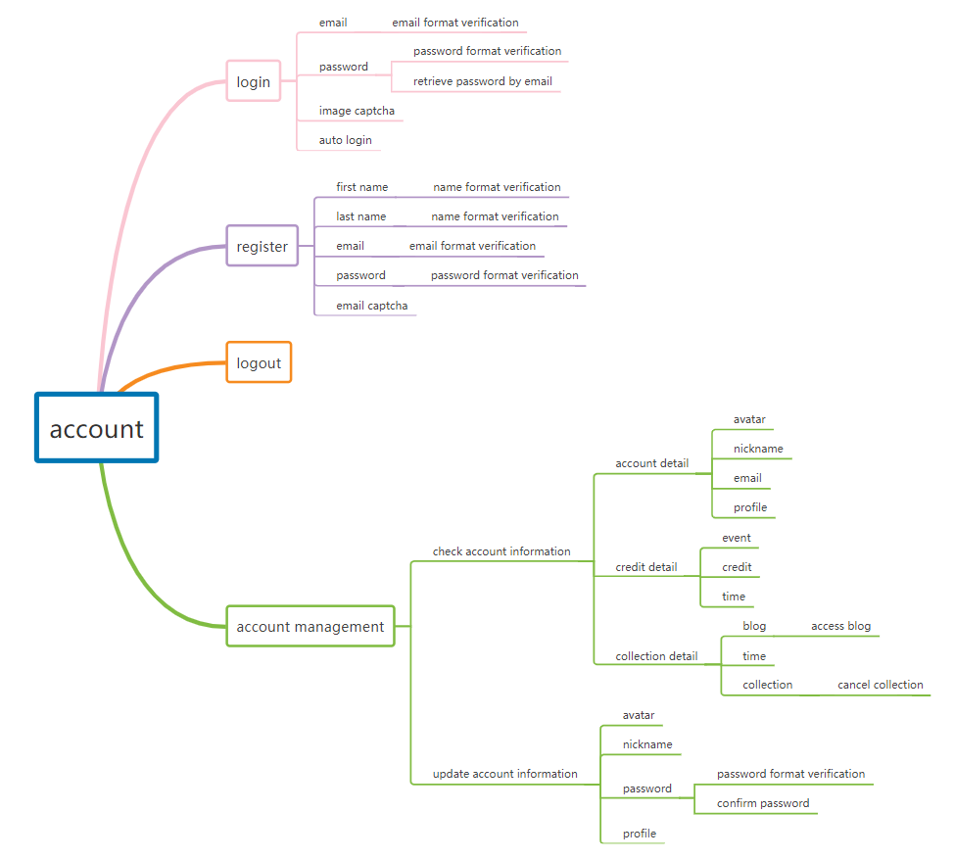

Functionality blog
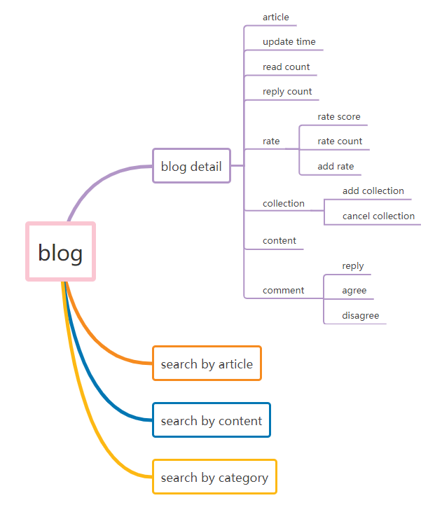

Functionality credit
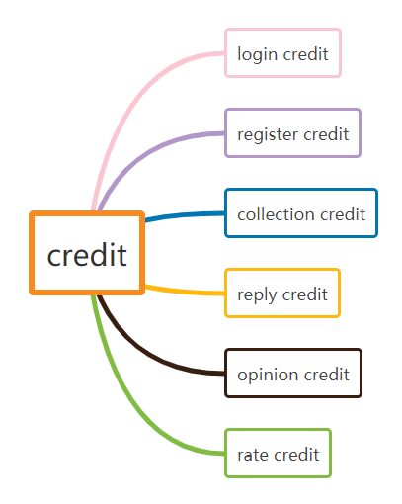

Functionality home
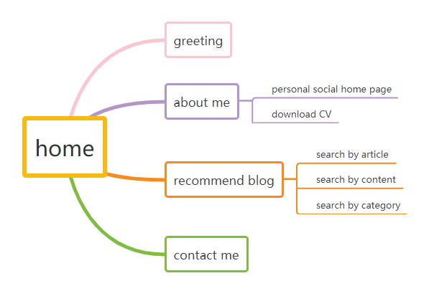

Functionality post-blog
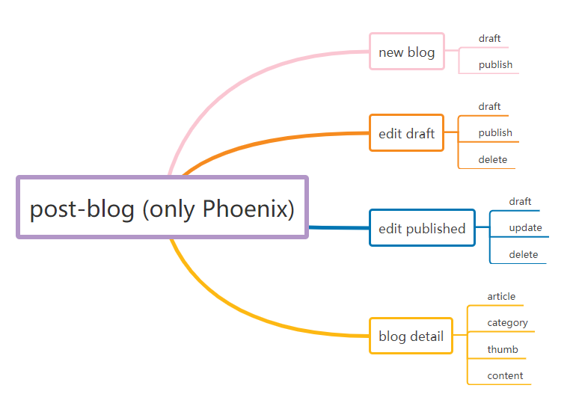

Technology design

Architecture design
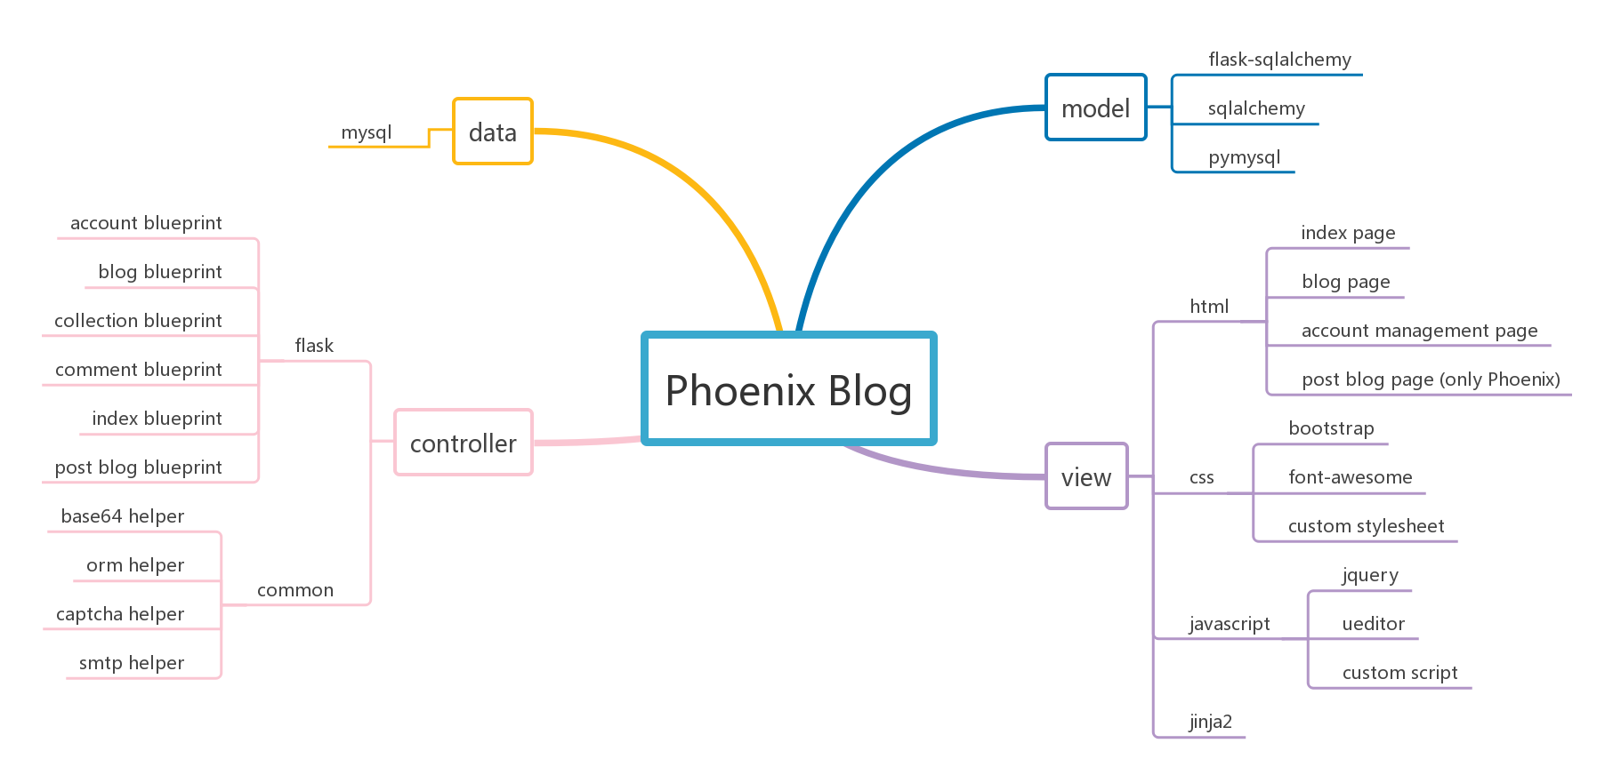

Development dependence

Server-side
- PyMySQL
Supports python operations on the database
- SQLAlchemy
Support python ORM of database operations
- Jinja2
Template engine supporting Flask rendering browser-side
- Flask
Server-side framework
- pillow
Support python image operation

Front-side
- JQuery
Support Ajax request and DOM element operations
- Bootstrap
Support responsive design
- ueditor
Support rich text editor
- font-awesome
Support icon and font resources

Data-side
- MySQL
Database

IDE
- PyCharm Professional
Integrated development environment

Debugging tool
- Postman
Debugging tool of server-side
- Chrome DevTools
Debugging tool of front-side

Database design

DataTable design

account
CREATE TABLE `account` (
`id` int (10) NOT NULL AUTO_INCREMENT,
`email` varchar (50) CHARACTER SET utf8 COLLATE utf8_general_ci NULL DEFAULT NULL,
`password` varchar (255) CHARACTER SET utf8 COLLATE utf8_general_ci NULL DEFAULT NULL,
`nickname` varchar (50) CHARACTER SET utf8 COLLATE utf8_general_ci NULL DEFAULT NULL,
`avatar` varchar (50) CHARACTER SET utf8 COLLATE utf8_general_ci NULL DEFAULT NULL,
`profile` varchar (255) CHARACTER SET utf8 COLLATE utf8_general_ci NULL DEFAULT NULL,
`credit` int (10) NULL DEFAULT NULL,
`createtime` datetime (0) NULL DEFAULT NULL,
`updatetime` datetime (0) NULL DEFAULT NULL,
PRIMARY KEY (`id`) USING BTREE
)

blog
CREATE TABLE `blog` (
`id` int(10) NOT NULL AUTO_INCREMENT,
`article` varchar (255) CHARACTER SET utf8 COLLATE utf8_general_ci NULL DEFAULT NULL,
`type` varchar (255) CHARACTER SET utf8 COLLATE utf8_general_ci NULL DEFAULT NULL,
`content` mediumtext CHARACTER SET utf8 COLLATE utf8_general_ci NULL,
`thumb` varchar (255) CHARACTER SET utf8 COLLATE utf8_general_ci NULL DEFAULT NULL,
`rate` tinyint(3) NULL DEFAULT NULL,
`ratecount` int (10) NULL DEFAULT NULL,
`readcount` int (10) NULL DEFAULT NULL,
`replycount` int (10) NULL DEFAULT NULL,
`draft` tinyint(1) NULL DEFAULT NULL,
`createtime` datetime (0) NULL DEFAULT NULL,
`updatetime` datetime (0) NULL DEFAULT NULL,
PRIMARY KEY (`id`) USING BTREE
)

collection
CREATE TABLE `collection` (
`id` int (10) NOT NULL AUTO_INCREMENT,
`email` varchar (50) CHARACTER SET utf8 COLLATE utf8_general_ci NULL DEFAULT NULL,
`articleid` int (10) NULL DEFAULT NULL,
`cancel` tinyint (1) NULL DEFAULT NULL,
`createtime` datetime (0) NULL DEFAULT NULL,
`updatetime` datetime (0) NULL DEFAULT NULL,
PRIMARY KEY (`id`) USING BTREE
)

comment
CREATE TABLE `comment` (
`id` int (10) NOT NULL AUTO_INCREMENT,
`email` varchar (50) CHARACTER SET utf8 COLLATE utf8_general_ci NULL DEFAULT NULL,
`articleid` int (10) NULL DEFAULT NULL,
`content` text CHARACTER SET utf8 COLLATE utf8_general_ci NULL,
`replyid` int (10) NULL DEFAULT NULL,
`agreecount` int (10) NULL DEFAULT NULL,
`disagreecount` int (10) NULL DEFAULT NULL,
`createtime` datetime (0) NULL DEFAULT NULL,
`updatetime` datetime (0) NULL DEFAULT NULL,
PRIMARY KEY (`id`) USING BTREE
)

credit
CREATE TABLE `credit` (
`id` int (10) NOT NULL AUTO_INCREMENT,
`email` varchar (50) CHARACTER SET utf8 COLLATE utf8_general_ci NULL DEFAULT NULL,
`type` varchar (50) CHARACTER SET utf8 COLLATE utf8_general_ci NULL DEFAULT NULL,
`event` varchar (255) CHARACTER SET utf8 COLLATE utf8_general_ci NULL DEFAULT NULL,
`target` int (10) NULL DEFAULT NULL,
`credit` int (10) NULL DEFAULT NULL,
`createtime` datetime (0) NULL DEFAULT NULL,
`updatetime` datetime (0) NULL DEFAULT NULL,
PRIMARY KEY (`id`) USING BTREE
)

Interfaces design

Server-side interfaces design

account controller
- @account_blueprint.route('/login', methods=['POST'])
Response for login
- @account_blueprint.route('/register', methods=['POST'])
Response for register
- @account_blueprint.route('/verification/image')
Response for login image captcha
- @account_blueprint.route('/verification/email', methods=['POST'])
Response for register email captcha
- @account_blueprint.route('/forget', methods=['POST'])
Response for login password forget
- @account_blueprint.route('/logout')
Response for logout
- @account_blueprint.route('/account')
Response for account page
- @account_blueprint.route('/account/profile', methods=['POST'])
Response for update account information

blog controller
- @blog_blueprint.route('/blog')
Response for first blog page
- @blog_blueprint.route('/blog/<int:current_page>')
Response for specific blog page
- @blog_blueprint.route('/blog-search-article/<int:current_page>-<keyword>')
Response for use specific page and keyword to search blog by article
- @blog_blueprint.route('/blog-search-content/<int:current_page>-<keyword>')
Response for use specific page and keyword to search blog by content
- @blog_blueprint.route('/blog-type/<int:current_page>-<type>')
Response for use specific page and category to search blog
- @blog_blueprint.route('/blog-article/<int:id>')
Response for blog detail
- @blog_blueprint.route('/rate', methods=['POST'])
Response for rate blog

collection controller
- @collection_blueprint.route('/collection', methods=['POST'])
Response for add collection
- @collection_blueprint.route('/collection/<int:article_id>', methods=['DELETE'])
Response for delete collection

comment controller
- @comment_blueprint.route('/comment', methods=['POST'])
Response for add comment
- @comment_blueprint.route('/reply', methods=['POST'])
Response for add reply
- @comment_blueprint.route('/opinion', methods=['POST'])
Response for add opinion

index controller
- @index_blueprint.route('/')
Response for home page
- @index_blueprint.route('/contact', methods=['POST'])
Response for contact me

post blog controller
- @post_blog_blueprint.route('/post-blog')
Response for post blog page
- @post_blog_blueprint.route('/post-blog/blog', methods=['POST'])
Response for post blog
- @post_blog_blueprint.route('/post-blog/load', methods=['POST'])
Response for load blog
- @post_blog_blueprint.route('/post-blog/blog/<int:id>', methods=['DELETE'])
Response for delete blog

Front-side interfaces design

Base.js
- loginOrRegister()
Request for login or register
- sendVerificationEmail ()
Request for email captcha
- sendForgetPasswordEmail ()
Request for forget password
- sendVerificationEmail ()
Request for image captcha

account.js
- updateProfile ()
Request for update account information
- cancelCollection(articleId)
Request for cancel collection

blog_article.js
- cancelCollection(articleId)
Request for cancel collection
- addCollection(articleId)
Request for add collection
- addComment(articleId)
Request for add comment
- addReply(articleId, commentId)
Request for add reply
- updateOpinion(commentId, type)
Request for update opinion
- addRate(articleId)
Request for add rate

blog_side.js
- searchBlog()
Request for search blog by article or content
- sortArticle()
Request for sort blog
- typeBlog(e)
Request for search blog by category

index.js
- sendContactEmail()
Request for contact

post_blog.js
- loadBlog(id)
Request for load blog
- postBlog(status)
Request for post blog
- deleteBlog()
Request for delete blog

Security, quality and usability

Security

